**Computer Networks**

**Lab 4a**

**Wireshark Lab:IP v8.0**

**Student Name: Phạm Ngọc Sang**

**Student No: 1813810**

1. **What is the IP address of your computer?**

Answer: 10.28.128.20

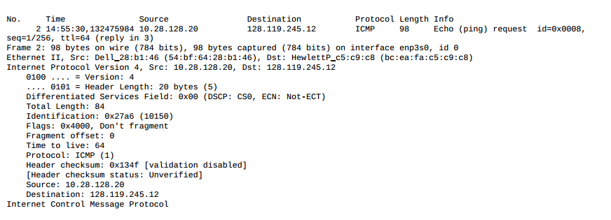

1. **Within the IP packet header, what is the value in the upper layer protocol field?**

Answer: ICMP (1)

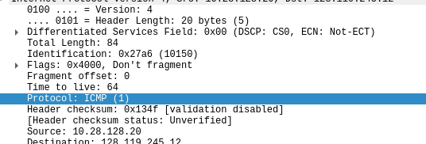

1. **How many bytes are in the IP header? How many bytes are in the payload of the IP datagram? Explain how you determined the number of payload bytes.**

Answer:

Header Length: 20 bytes

Payload of the IP datagram: 64 bytes

The total length: 84 bytes, Payload = total - header = 64

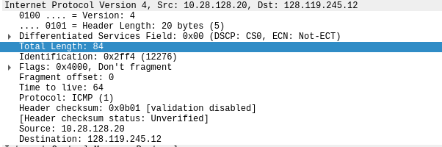

1. **Has this IP datagram been fragmented? Explain how you determined whether or not the datagram has been fragmented.**

Answer: No

Flags: Don't fragment and fragment offset = 0

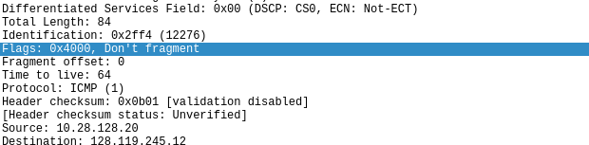

1. **Which fields in the IP datagram always change from one datagram to the next within this series of ICMP messages sent by your computer?**

Answer: Identification, Time to live, Header checksum

1. **Which fields stay constant? Which of the fields must stay constant? Which fields must change? Why?**

Answer:

Constant fields:

* version (IPv4 always used)
* header length (always using IPv4)
* source IP (my computer’s IP address doesn’t change)
* destination IP (usc.edu’s IP address doesn’t change)
* differentiated services (same protocol)
* upper layer protocol (same protocol)

Fields must stay constant:

* Version
* Header length
* Source IP
* Destination IP
* Differentiated Services
* Upper Layer Protocol (same protocol)

Fields must change:

* Identification(IP packets have different ids)
* Time to live (traceroute increments each subsequent packet)
* Header checksum (header changes)

1. **Describe the pattern you see in the values in the Identification field of the IP datagram.**

Answer: The value increase with each datagram

1. **What is the value in the Identification field and the TTL field?**

Answer:

Identification value: 0x2ff4 (12276)

TTL value: 64

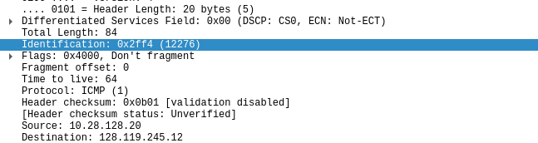

1. **Do these values remain unchanged for all of the ICMP TTL-exceeded replies sent to your computer by the nearest (first hop) router? Why?**

Answer:

The identification change because it has to have a unique value.

TTL doesn’t change because it always the same

1. **Find the first ICMP Echo Request message that was sent by your computer after you changed the Packet Size in pingplotter to be 2000. Has that message been fragmented across more than one IP datagram?**

Answer: Yes, this packet has been fragmented across more than one IP datagram

1. **Print out the first fragment of the fragmented IP datagram. What information in the IP header indicates that the datagram been fragmented? What information in the IP header indicates whether this is the first fragment versus a latter fragment? How long is this IP datagram?**

Answer: The fragment offset is 0. It tells us that is the first fragment

1. **Print out the second fragment of the fragmented IP datagram. What information in the IP header indicates that this is not the first datagram fragment? Are the more fragments? How can you tell?**

Answer: We can tell that this is not the first fragment, since the fragment offset is 1480. It is the last fragment, since the more fragments flag is not set.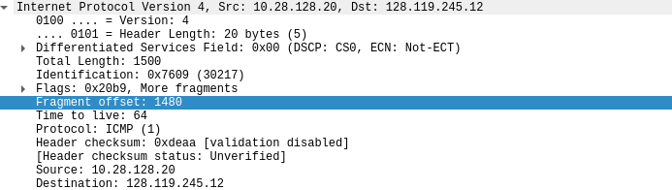

1. **What fields change in the IP header between the first and second fragment?**

Answer: total length, flags, fragment offset, and checksum.

1. **How many fragments were created from the original datagram?**

Answer: 3 fragments

1. **What fields change in the IP header among the fragments?**

Answer: fragment offset, checksum